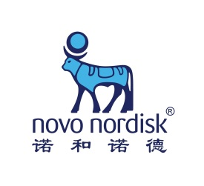
NN-CAS Get-Together Day 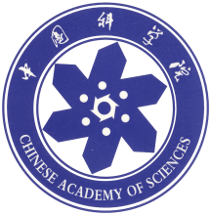

Program

Institute of Biophysics, Chinese Academy of Science
August 25, 2016

Information on the Novo Nordisk and
the Chinese Academy of Sciences

Novo Nordisk
Novo Nordisk is a global healthcare company with 90 years of innovation and
leadership in diabetes care. The company also has leading positions within
haemophilia care, growth hormone therapy and hormone replacement therapy.
Headquartered in Denmark, Novo Nordisk employs approximately 42,300
employees, of which 20% of the employees are within Research & Development, in
75 countries, and markets its products in more than 180 countries.
In 1997, Novo Nordisk established the first biotechnology R&D center among
multinational pharmaceutical companies in Beijing, China. Novo Nordisk Research
Center China is currently also one of the biggest R&D centers set up by multinational
pharmaceutical companies in China.
For more information please refer to our web page: http://www.novonordisk.com.cn

Chinese Academy of Sciences
Being China’s top academic institution in science and technology and the national
integrated R&D center in natural sciences and high technology, the Chinese
Academy of Sciences has made important contributions to China’s scientific
advancement and social development since its establishment in 1949. It has about
100 research institutes, two universities, and about 60,000 professional staff and
45,000 graduate students.
The Chinese Academy of Sciences engages above all in the basic research, strategic
high technology research and research relevant to the sustainable development of
economy and society, focuses on the solutions to science and technology issues of
fundamental, strategic and forward looking importance in China’s modernization
process, and provides scientific basis and sources of technological means for
promoting the overall sustainable development of China’s economy and society.
For more information please refer to our web page: http://english.cas.cn or contact
us at bulletin@mail.casipm.ac.cn

NN-CAS Get-Together Day

Organizer: Novo Nordisk-Chinese Academy of Sciences Research Fund
Organizing Committee:
Novo Nordisk: Prof. Børge Diderichsen, Dr. Baoping WANG, Dr. Fang ZHANG, Dr. Zhiru YANG, Dr. Xujia ZHANG, Mr. Ning WU, Ms. Hao WANG
CAS: Prof. Tao Xu, Prof. Ming-wei WANG, Ms. Dongyao WANG, Ms. Ying LI
Secretariat: Ms. Dongyao WANG, Ms. Ying LI, Ms. Hao WANG
Time: August 25, 2016, 9:00-17:00
Venue:
Institute of Biophysics, CAS: No.15, Datun Rd, Chaoyang District, Beijing.
Meeting Room: Room 9501 in Protein Building
中科院生物物理研究所：北京市朝阳区大屯路15号；会场：蛋白质楼9501会议室
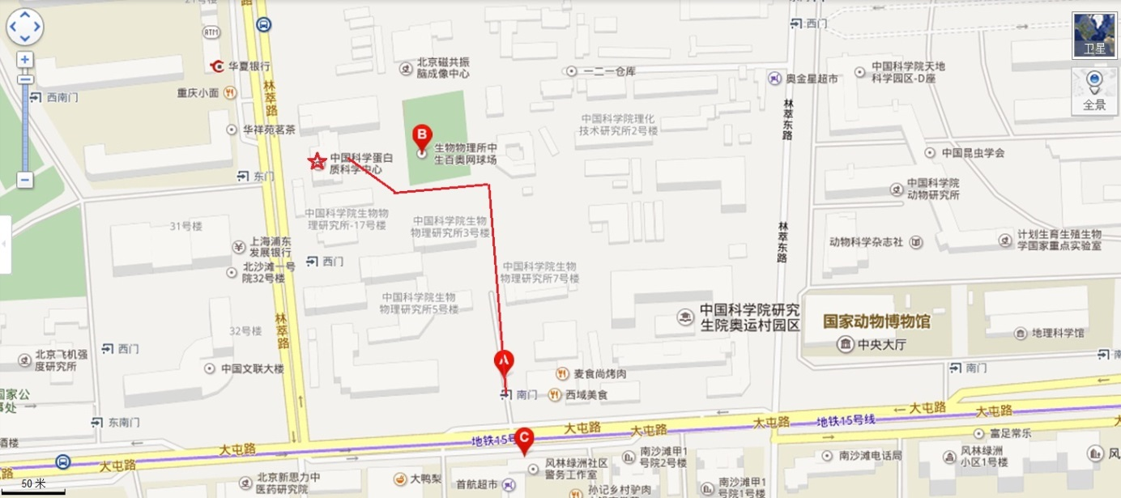
Dinner:
- Restaurant: Meizhou Dongpo (Olympic area) 眉州东坡酒楼（国奥村店）
- Transport to restaurant: one 33-seat shuttle bus and ride-sharing/taxi

The purposes of the NN-CAS Get-Together Day
• To identify new joint projects that may generate value to CAS and Novo Nordisk within NN’s core areas.
• To inform CAS scientists about Novo Nordisk R&D and Novo Nordisk Research Centre China (NNRCC); and to inform NN scientist about CAS recent development in life science/drug R&D and representative institutions, to increase the general interest in cooperation by both sides.
• To update new requirements on bioethics and human samples according to Chinese regulations and/or Novo Nordisk’s policy.
• To present examples of excellent joint projects from NN-CAS Research Fund.
• To create networks and facilitate joint applications for 2016 and 2017 Calls.

Venue
Institute of Biophysics, Chinese Academy of Science / 中科院生物物理研究所
Participants
Relevant CAS scientists and Novo Nordisk Scientists

Program
08:30-09:00 | Registration
09:00-09:05 | Welcome  Dr. Tao XU, Director General of Institute of Biophysics, CAS
09:05-12:15 | Plenary Session
Co-Chairs: | Dr. Ming-Wei WANG, Director of the National Center for Drug Screening  Dr. Tao XU, Director General of Institute of Biophysics, CAS
09:05-09:20 | Opening remark & Introduction of CAS recent development in life science/drug R&D  Dr. Yongqing ZHANG, Deputy Director-General of the Bureau of Frontier Sciences and Education,
09:20-09:35 | Introduction of NN-CAS Research Fund/Update of new requirements  Dr. Baoping WANG and Dr. Fang ZHANG, NNRCC
09:35-10:35 | Introduction of NNR&D and NNRCC Research areas  Dr. Fang ZHANG, NNRCC, Discovery Biology China  Dr. Xujia ZHANG, NNRCC, E.coli Research China  Dr. Zhiru YANG, NNRCC, Discovery Technology China
10:35-10:55 | Group Photo & Coffee break
10:55-11:25 | Presentation of selected CAS institutes  Dr. Yungui YANG, Beijing Institute of Genomics  A Brief Introduction of Beijing Institute of Genomics, CAS  Dr. QU Hongzhu, Beijing Institute of Genomics  Identify Novel SLE Targets Using GWAS and ENCODE Non-coding Variants
11:25-12:15 | Presentations of success stories from NN-CAS Research Fund
Dr. Dawei ZHANG, Institute of Industrial Biotechnology, Tianjin
High-level secreted producing of recombinant FGF21 protein in bacteria
Dr. Yong GAN, Shanghai Institute of Materia Medica
Functional Particle Design for Oral Insulin Delivery
12:15-12:55 | Lunch
12:55-13:35 | Tour of IBP  (in two groups: one focusing on protein science; another for Animal facility and related).
13:35-16:05 | Workshop: Metabolic disease study and discovery technology
Co-Chairs: | Dr. Ming-Wei WANG, Director of the National Center for Drug Screening  Dr. Fang ZHANG, VP in NNRCC  Dr. Zhiru YANG, VP in NNRCC
13:35-14:05 | Dr. Ping HU, Shanghai Institute of Biochemistry and Cell Biology  Making strong muscles
14:05-14:35 | Dr. Qiurong DING, Institute of Nutrition  Genome editing for disease modelling and disease treatment
14:35-15:05 | Dr. Guanghui LIU, Institute of Biophysics  Using stem cell and gene editing techniques to study and treat aging associated disorders
15:05-15:35 | Dr. Rui GONG, Wuhan Institute of Virology  Development of better and novel biotherapeutics based on antibody Fc engineering
15:35-16:05 | Dr. Qiannan HU, Tianjin Institute of Industrial Biotechnology  Biochemical structure transformation-guided enzyme discovery
16:05-16:15 | Break
16:15-16:45 | Free discussion (including Poster presentations, if any)
16:45-17:00 | Conclusions (NN-CAS RF Board)
17:30-20:30 | Dinner: Meizhou Dongpo Restaurant(near Olympic)  (leave IBP for restaurant at 17:15)

Program on 26 Aug 2016 in NNRCC

09:00-09:15 | Welcome & Introduction
09:15-10:30 | Tour of NNRCC  Open Labs, Mini-Pilot & Dog facility
10:30-11:30 | Group discussion  Discovery Technology – Autumn conf. room  Discovery Biology – Spring conf. room  Ecoli. Research - Summer conf. room
11:30 – 12:30 | Lunch & networking
12:30 | Leave NNRCC for Airport or to subway station (生命科学园地铁站)

NNRCC Address: 北京市昌平区生命园路20号2号楼

Transport to NNRCC:

- 为了方便大家来研发中心参观，我们安排了一辆巴士，如您选择乘坐巴士，请您务必26日早上8点前在中科院生物物理研究所南门（大屯路上，见下图）集合上车。8点整发车去诺和诺德中国研发中心。车牌号: 京E00729，牛师傅电话：13716662183 王昊：13466710658

参观完毕后，需去机场的，我们安排送到机场。需回市内的，我们送到地铁站。

- 如果您选择自行前往，请参考来研发中心的路线图。

如果您有任何问题请与王昊（13466710658）联系。

