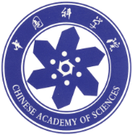
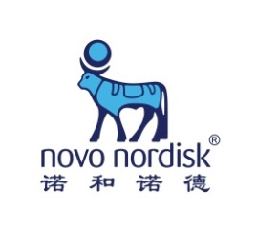
Novo Nordisk–Chinese Academy of Sciences Research Fund
10 Year Anniversary Symposium
“Diabetes, Obesity and Technology”
1st November, 2017

Participant Registration Form

- Participant information
Name: |  | Position: |  |  | Affiliation:
Mobile: |  |  |  | Email:

Meal reservation (covered by the meeting)

(International Conference Centre, UCAS国科大国际会议中心)
☐ Lunch,  1 Nov 2017 |  |  |  | ☐ Dinner,  Nov 2017

Hotel reservation *: participant’s own expense
☐ Swan Lakeview Hotel中建雁栖湖景酒店(CNY700) |  |  | ☐ UCAS Hotel国科大会议中心酒店(CNY300-350) |  |  | ☐ no need
☐ 31 Oct 2017 |  |  | ☐ 1 Nov 2017 |  |  | ☐ Extra nights (indicate date):

Local transportation
☐ Self-drive (by own expenses)
☐ Need local transportation provided by the meeting: please select below
Between downtown Beijing(IBP, CAS) and Huairou (UCAS)* |  |  |  | Between Airport (T3) and Huairou (UCAS)*
☐ Outbound, Late afternoon, 31 Oct 2017 | ☐ Outbound,  Early morning, 1 Nov. 2017 |  |  | ☐ Outbound,  16:00, 31 Oct 2017 |  |  | ☐ Outbound,  19:00, 31 Oct  2017
☐ Inbound,  After meeting, 1 Nov 2017 | ☐ Inbound,  Early morning, 2 Nov 2017 |  |  | ☐ Inbound,  18:30, 1 Nov 2017 |  |  | ☐ Inbound,  7:00, 2 Nov  2017

*Notice: We will provide an official meeting announcement for your business trip.
Send Registration Form to Ms. Jingjing Cai at JGJC@NOVONORDISK.COM

